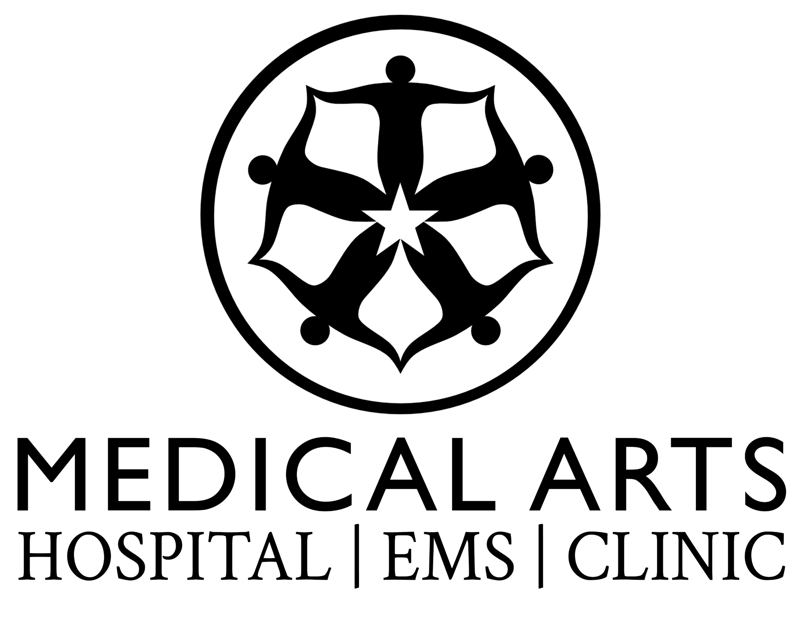

Assistant Director of Nursing (ADON)

Rural Hospital / Critical Access Hospital (CAH)

Job Title
Assistant Director of Nursing (ADON)

Department
Nursing Administration

Reports To
Director of Nursing (DON) / Chief Nursing Officer (CNO)

Position Summary
The Assistant Director of Nursing (ADON) assists the Director of Nursing in the leadership, management, and coordination of nursing services to ensure high-quality patient care and compliance with federal, state, and regulatory standards.
In a rural hospital environment, the ADON plays a key operational leadership role in maintaining survey readiness, staff competency, and regulatory compliance while supporting efficient operations across multiple departments.
The ADON collaborates with hospital leadership, medical staff, and clinical departments to ensure care delivery aligns with Centers for Medicare & Medicaid Services (CMS) Conditions of Participation, patient safety standards, and quality improvement initiatives.

Essential Duties and Responsibilities

Nursing Operations & Leadership
- Assist the Director of Nursing with the daily operations of the nursing department including inpatient, emergency, outpatient, and swing bed services as applicable.
- Provide leadership and supervision to nursing staff to ensure safe, effective, and patient-centered care.
- Serve as administrative nursing leadership in the absence of the Director of Nursing.
- Support coordination of staffing and scheduling to maintain adequate nurse-to-patient coverage.
- Assist with departmental strategic planning and performance improvement.
- Assist with budget preparation and monitor departmental revenue and expenses
- Assist with staff scheduling.

CMS Compliance & Regulatory Oversight
- Support compliance with **Centers for Medicare & Medicaid Services Conditions of Participation and Critical Access Hospital standards.
- Assist in maintaining continuous survey readiness for federal and state inspections.
- Participate in policy development and implementation to ensure regulatory compliance.
- Monitor nursing documentation to ensure adherence to regulatory and clinical standards.
- Support preparation for regulatory reviews including:
  - State health department surveys
  - CMS certification reviews
  - Quality audits and accreditation processes.

Quality Improvement & Patient Safety
- Participate in the hospital’s Quality Assurance and Performance Improvement (QAPI) program.
- Monitor clinical quality indicators and assist in implementing improvement initiatives.
- Support infection prevention and control activities.
- Assist with incident reporting, risk management, and patient safety initiatives.
- Participate in multidisciplinary committees focused on quality outcomes.

Staff Development & Competency
- Assist in recruitment, onboarding, orientation, and retention of nursing staff.
- Ensure staff competency validation and annual skills assessments.
- Assist with maintaining organized and accurate nursing department files to support regulatory compliance, staff competency tracking, and operational efficiency.
- Support continuing education and professional development programs.
- Mentor and coach nursing staff to strengthen clinical skills and leadership capacity.

Clinical Support
- Provide direct clinical support when needed to maintain patient care services.
- Assist with patient flow coordination across departments.
- Support collaboration between physicians, advanced practice providers, and nursing staff
- Promote a multidisciplinary approach to care delivery by encouraging teamwork, shared decision-making, and collaborative problem-solving across clinical and non-clinical departments
- Provide operational and clinical support to Case Management services to promote effective care coordination, discharge planning, and utilization management.
- Support the Infection Prevention and Control program in collaboration with the Infection Preventionist to ensure compliance with CMS, CDC, and state regulations.
- Provide leadership support for Trauma services to ensure preparedness, regulatory compliance, and high-quality trauma care delivery.

Policy & Procedure Management
- Assist with development, implementation, and review of nursing policies and procedures.
- Ensure policies align with CMS regulations, evidence-based practice, and hospital standards.
- Maintain appropriate documentation and departmental reporting.

Qualifications

Education
- Bachelor of Science in Nursing (BSN) required
- Master’s degree in Nursing or Healthcare Administration preferred

Licensure
- Current Registered Nurse (RN) license in the State of Texas
- Maintain certifications in BLS,ALS, PALS, TNCC, NRP.

Experience
- Minimum 5-7 years clinical nursing experience
- Minimum 3-5 years supervisory or leadership experience
- Experience in rural hospital, Critical Access Hospital, or community hospital preferred

Knowledge, Skills, and Abilities
- Strong understanding of CMS Conditions of Participation and rural hospital regulatory requirements
- Knowledge of QAPI programs and survey readiness
- Ability to lead and motivate multidisciplinary healthcare teams
- Strong communication and conflict resolution skills
- Excellent organizational and problem-solving abilities
- Ability to function effectively in a resource-limited rural healthcare environment

Working Conditions
- Hospital clinical and administrative environment
- May require evenings, weekends, and on-call responsibilities
- May require working shifts during staffing shortages or emergencies
- Ability to respond to operational needs during staffing shortages or emergencies

